**CS275 Scrum Master Assignment - Sprint 1**

1. Do these Sprint Specific tasks before your Sprint Planning Meeting the Main tab, on the Sprint Plan section:
   1. Add Sprint 6 and its dates
   2. Change the "Remarks" Header to "Scrum Master"
   3. Put the name of the person who has chosen to run each Sprint on the Sprint's line.

Old: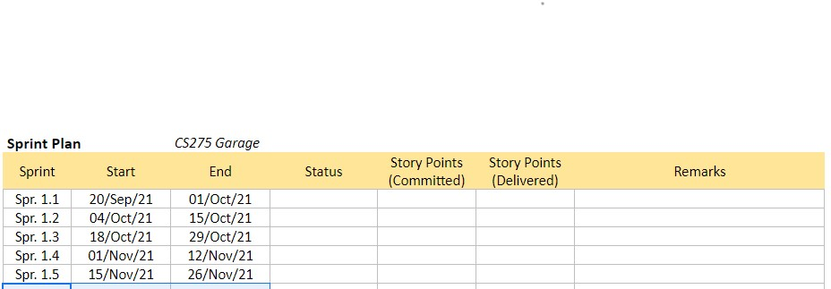

New:

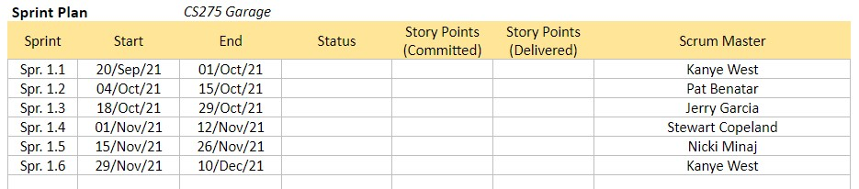

* 1. Assure each member of the team clones the repository and attempt a commit and push of a sample file to assure they know how to do it.

1. You will run the Sprint Planning meeting and record the results of the meeting in the planning worksheet. This entails deciding which user stories to implement and using the planning poker cards to determine how many story points each story will take. Record in the worksheet which team member will take a user story, how many points the team member believes it will be. Scrum masters should take on tasks, but may not take on as many tasks as team members as the scrum master has duties associated with that position.
2. After your planning meeting you will document the meeting to me. I will post an assignment on this due Wednesday. As you’re running your meeting, keep in mind:
   1. Did you feel like you were in control of the meeting? Why or why not?
      1. Yes, I felt like I was in control of the meeting because the group was very responsive and cooperative
   2. Did each person in the group offer to take tasks or did you have to suggest tasks to individuals? What do you think were the motive for each member in either hanging back or taking on the tasks?
      1. As a group we figured out what was the best task for each person to take. We all wanted each other to have responsibilities to ensure the project was running smoothly.
   3. How confident are you that all story points will be implemented?
      1. Very confident because it seemed like everyone could handle their responsibilities well
   4. What help might you need during the rest of the sprint?
      1. We might need more guidance and structure as to how we should create our project
3. Your team meets M W F and either W or R depending on your team’s schedule. You are responsible for filling out the Daily Stand Up form each time you meet for a total of 4 forms per week and 8 forms per turn as Scrum Master. These forms need to be submitted the day of the meeting
4. After your Planning Session, download a copy of the planning sheet commit, then push it to your repository by 11:59 tonight.